**An overview of machine learning algorithms and how they work**

[[Phindulo Makhado, MSc Coms Sci Cand, MSc Fin Eng](https://medium.com/@phindulo60?source=post_page-----fc3086c656e3--------------------------------)](https://medium.com/@phindulo60?source=post_page-----fc3086c656e3--------------------------------)

[Phindulo Makhado, MSc Coms Sci Cand, MSc Fin Eng](https://medium.com/@phindulo60?source=post_page-----fc3086c656e3--------------------------------)

·

[Follow](https://medium.com/m/signin?actionUrl=https%3A%2F%2Fmedium.com%2F_%2Fsubscribe%2Fuser%2F23285d252ef0&operation=register&redirect=https%3A%2F%2Fmedium.com%2F%40phindulo60%2Fan-overview-of-machine-learning-algorithms-and-how-they-work-fc3086c656e3&user=Phindulo+Makhado%2C+MSc+Coms+Sci+Cand%2C+MSc+Fin+Eng&userId=23285d252ef0&source=post_page-23285d252ef0----fc3086c656e3---------------------post_header-----------)

3 min read

·

Mar 30

3

Have you ever wondered how Siri can understand your voice commands or how Netflix knows what movie or TV show you’ll enjoy watching next? The answer is machine learning. Machine learning is the process by which computers learn from data and use that knowledge to make decisions or predictions without being explicitly programmed to do so. And at the heart of machine learning are algorithms — mathematical formulas that process data and make predictions.

In this article, we’ll provide an overview of machine learning algorithms and how they work. We’ll cover the three main categories of machine learning algorithms — supervised learning, unsupervised learning, and reinforcement learning — and explore some examples of each.



Robot Kid reading his book

**Supervised Learning Algorithms**

Supervised learning algorithms are used when we have labeled data — that is, data that has been categorized or classified in some way. The goal of a supervised learning algorithm is to use this labeled data to learn how to predict the category or classification of new, unlabeled data.

For example, let’s say we have a dataset of images of cats and dogs, labeled as such. We can use a supervised learning algorithm to learn from this labeled data and then make predictions on new, unlabeled images. One common supervised learning algorithm is logistic regression, which is used to classify data into one of two categories (e.g., cat or dog).

Another common supervised learning algorithm is the decision tree, which uses a tree-like structure to classify data based on a series of decisions. For example, a decision tree could be used to predict whether or not a customer will buy a product based on their age, income, and other factors.

**Unsupervised Learning Algorithms**

Unsupervised learning algorithms, as the name suggests, are used when we don’t have labeled data. Instead, these algorithms are tasked with identifying patterns or relationships in the data on their own.

One common unsupervised learning algorithm is clustering, which groups similar data points together. For example, a clustering algorithm could be used to group customers with similar purchase histories together for targeted marketing campaigns.

Another unsupervised learning algorithm is dimensionality reduction, which is used to simplify complex datasets by reducing the number of variables or dimensions. This can make it easier to analyze and visualize the data.

**Reinforcement Learning Algorithms**

Reinforcement learning algorithms are used in situations where an agent (e.g., a robot or game player) interacts with an environment and receives feedback (in the form of rewards or penalties) based on its actions. The goal of a reinforcement learning algorithm is to learn how to take actions that maximize the total reward over time.

For example, reinforcement learning algorithms can help train systems to make better decisions based on past experiences and current situations. For instance, a train system facing delays due to congestion could use a reinforcement learning algorithm to manage traffic more efficiently. The algorithm would learn to minimize delays and improve passenger satisfaction by rewarding the train system for reaching stations on time and penalizing it for delays. The algorithm could also identify potential delays and take proactive measures to prevent them. Additionally, a reinforcement learning algorithm could be trained to detect potential safety hazards, such as obstructions on the tracks, and take action to prevent accidents. Overall, reinforcement learning algorithms have the potential to revolutionize train operations by making them more efficient and safer.

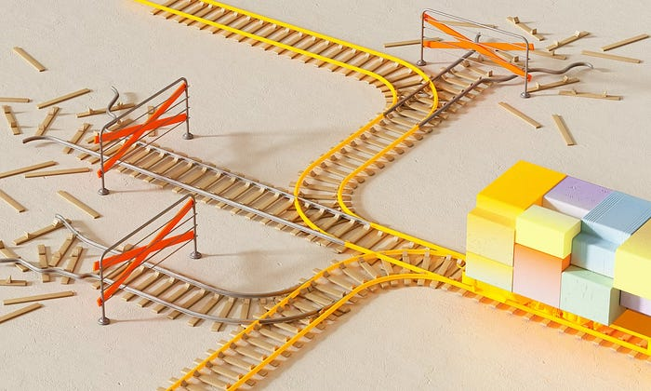

**Conclusion**

Machine learning algorithms are at the heart of the machine learning process. They allow computers to learn from data and make predictions or decisions without being explicitly programmed to do so. By understanding the different categories of machine learning algorithms and their applications, we can begin to appreciate the power and potential of this technology.